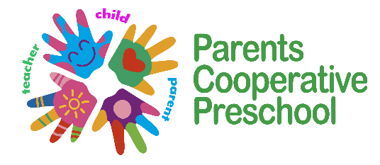
Parents Cooperative Preschool
320 South Main Street
Fort Atkinson, WI 53538
920.563.7252 www.pcpfort.com parentscoop@att.net

Supply List 2024-2025
3-Year-Old Room w/ Miss. Emily (E.Yavuzcetin)
2- 5 oz Dixie Brand Cups
1-packs Baby Wipes
2-packs disinfectant wipes/canasters
1-Elmers Liquid Glue Bottle
1- Paper Towel Roll
1-pack of brown lunch paper bags
1-pack of white paper lunch bags
1-Roll Gorilla Tape (any color)

Ziplock bag of a clean set of clothes/underwear/diapers-pullups/socks with name on all items, to be kept in backpack.

If using diapers or pullups, please provide some in your child’s size to keep in backpack or bag for each class day; please check back pack daily to replenish as needed

